This document provides the necessary instructions for completing the Week 13 lab exercises.

Exercise 1: Merge-Sort algorithm

In the picture below, we depict the merge algorithm for merging the contents of arrays $S_{1}$ and $S_{2}$

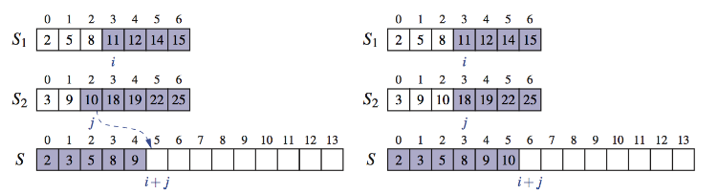

The illustration shows the case i=3, j=2. We compare S1[3] and S2[2]:
- We have S1[3] > S2[2]
- Therefore, we can assign S[3+2] = S[5] = S2[2]

Continue the merging process for all the elements.

Exercise 2: Merge-Sort algorithm

In the main method of MegeSort.java from Lesson12Examples, Use the implementation of Merge-Sort with Queues to sort a queue of String objects.

Exercise 3: Quick-Sort algorithm

Consider the sequence: 5, 4, 3, 9, 2 , 7.

Depict the execution of the quick-sort algorithm using a binary tree as shown in the lesson slides.

Exercise 4: Quick-Sort algorithm

In Lesson12Examples project, add a class Student with the following instance variables:
private String studentId;
private string name;
private int seniority;

Provide the necessary constructors and getters/setters.

In the main method of QuickSort.java from Lesson12Examples, create a Comparator object for student objects.

Create an array of student objects and use the quickSort method to sort them.

